32.1: a) 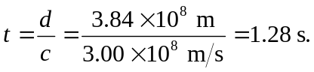
b) Light travel time is:

